| ***CITY OF SPRINGFIELD, OREGON***  Development and Public Works Department |  | *225 FIFTH STREET*  *SPRINGFIELD, OR 97477*  *(541) 726-3753*  *FAX (541) 726-3689*  *www.springfield-or.gov* |
| --- | --- | --- |

March 15, 2021

**HIGH BANKS & THURSTON OVERLAY #P21152**

**Q.** For the added sidewalk, if I add 591 square feet to the bid item of 1300 square feet, I don’t come up with 2482 square feet.  I only get 1891 square feet.  Can you explain?

**A.** Line #44 on the detail sheet should now be a total of 1891 sq. ft. The 1891 reflects the original 1300 sq. ft., plus the additional 591 that’s being added. Please cross off the 1300 on the detail sheet and write in 1891.

**Q.** I am unable to find where the 18” ICTB Repair bid item goes.  Can someone give me some help?  Is this a placeholder for a price because by coincidence it is 10” of the 12” ICTB bid quantity?

**A.** The 18" ICTB repair bid item is for replacing any ICTB which fails a proof roll. Hopefully we don't have any, but we assumed 10% of the ICTB area may need to be repaired.

**Q**. Is the asphalt patching at the new ramps incidental to the ramps bid item #45 or is the asphalt paid under bid items #37 & #38?  In the last bid P21157 Mohawk and Olympic Overlay the asphalt patching was incidental to the ramp construction.

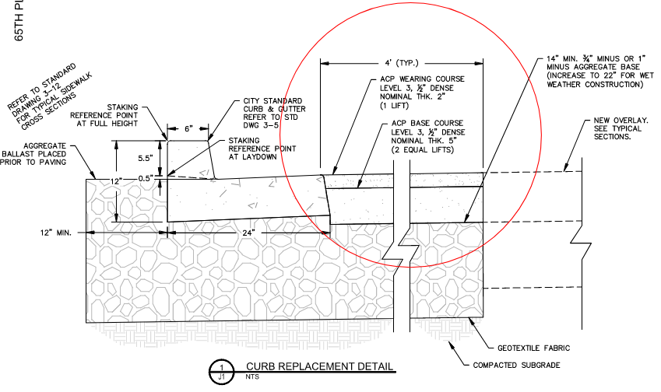

**A.** Yes, the area circled below is to be incidental to and paid for under the bid item “retrofit concrete sidewalk ramps”.